# Salt 4.2.1 ‘Panic Button’ installation instructions

## How to set permissions for services so that the "Stop Mail Sending Service" Button works.

If the "Stop Mail Sending Service" Button Text is not getting set then it is probably due to the website not having permission to query the service.

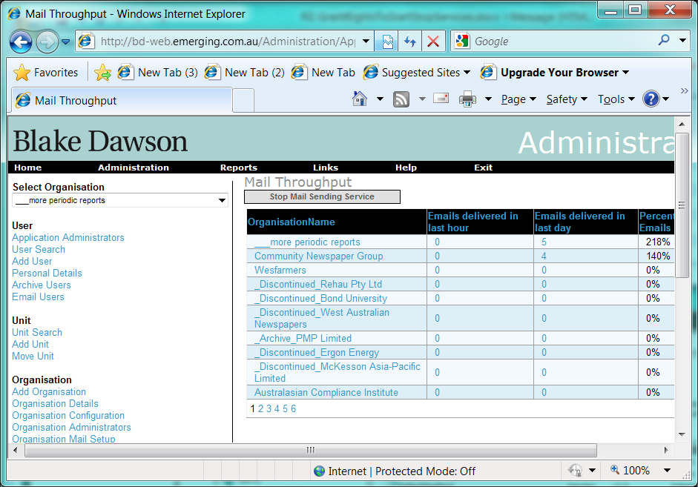

In the installation of the website being documented, the Application Pool was ‘salt-secure’ with an identity of ASPNET2.

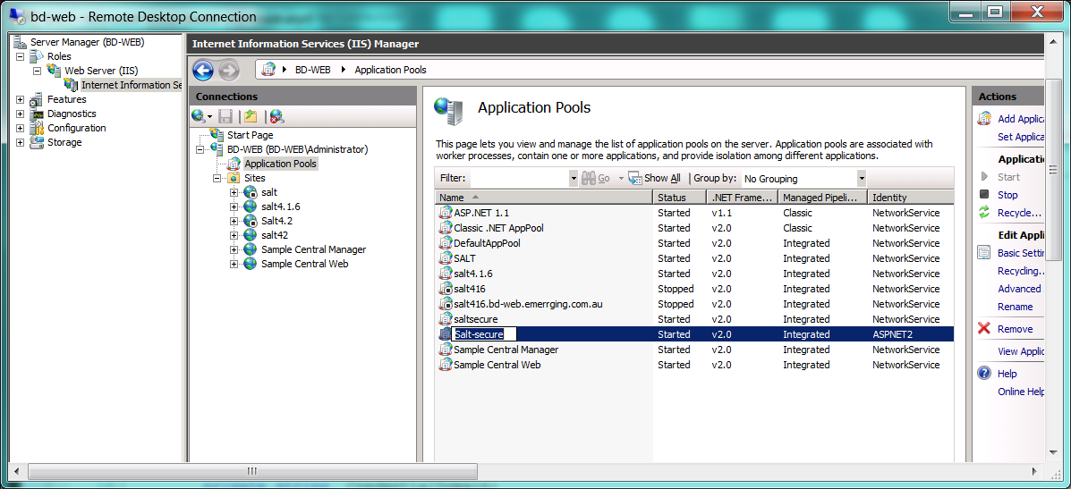

The website is BD-Web and the Service name is SALTSendMail1:

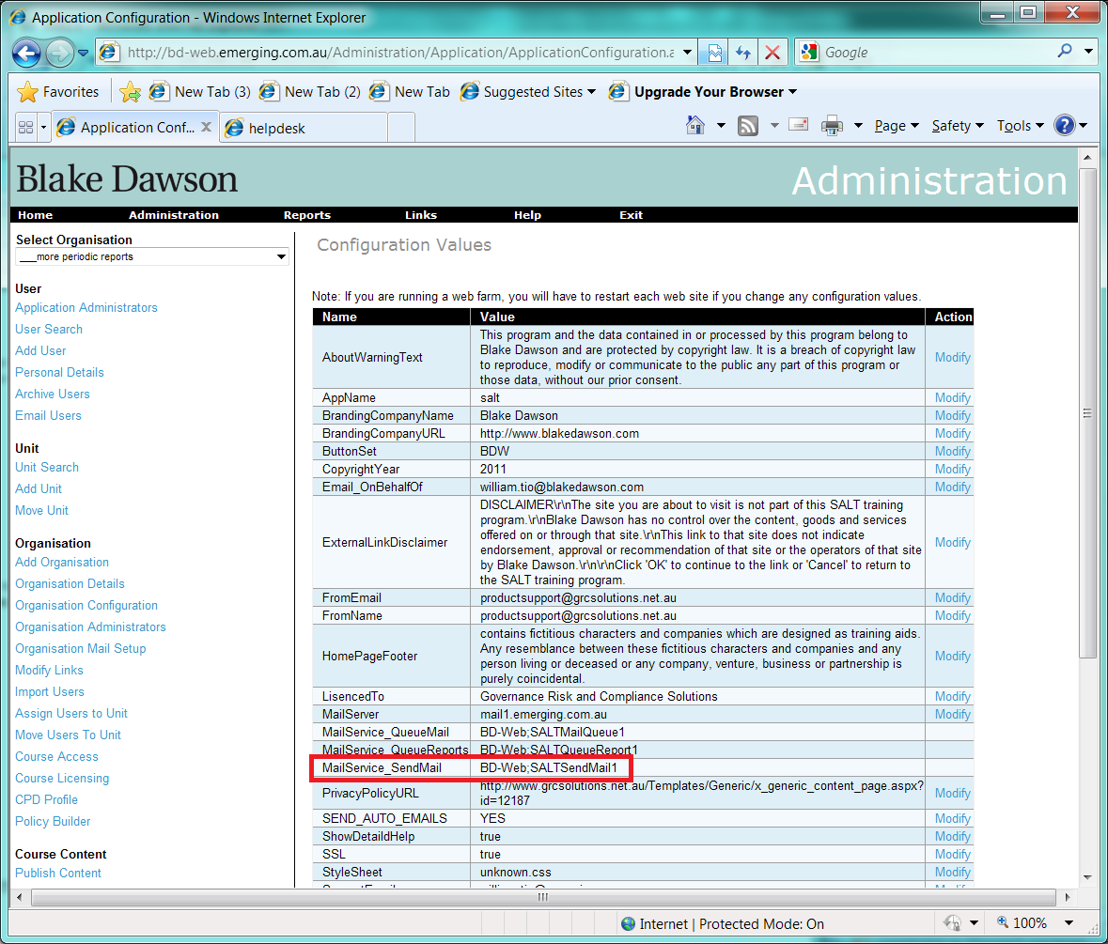

The command to grant permissions would be:

C:\Program Files (x86)\Windows Resource Kits\Tools\subinacl.exe /service \\bd-web\SALTsendMail1 /Grant=bd-web\ASPNET2=F